NEW ORLEANS COMMUNITY MOBILE TESTING PLAN

COVID-19 has rapidly spread worldwide and through the United States, with significant disruption to community life and economic situation. Its effects, however, have not been uniform and are widely dependent on several key factors: 1) access to reliable testing; 2) healthcare system capacity and accessibility; 3) underlying demographic and medical conditions of individuals; 4) long-established structural inequities in the social determinants of health.

Louisiana (and New Orleans in particular) has been able to test its residents for COVID-19 infection at some of the highest levels in the world, providing a clear picture of widespread community impact. Using one model, up to 15% of New Orleanians may have been infected with the virus within a 6-8 week time period. With a case fatality rate around 5% of all positive tests, the morbidity of the disease cannot be understated and likely reflects the City’s historic disproportionate rates of poor health outcomes, particularly for Black residents.

As the first city to implement the Federal drive through testing pilot, New Orleans (and neighboring Jefferson Parish) tested almost 15,000 residents in 3 weeks at no cost. As successful as this program was, it still presented barriers to individuals without access to a car or a Louisiana ID, and those for whom distrust of the government and medical system made it unlikely that they would seek care. An analysis of addresses of individuals who received testing at the drive through sites revealed neighborhoods with low usage (stars on map):

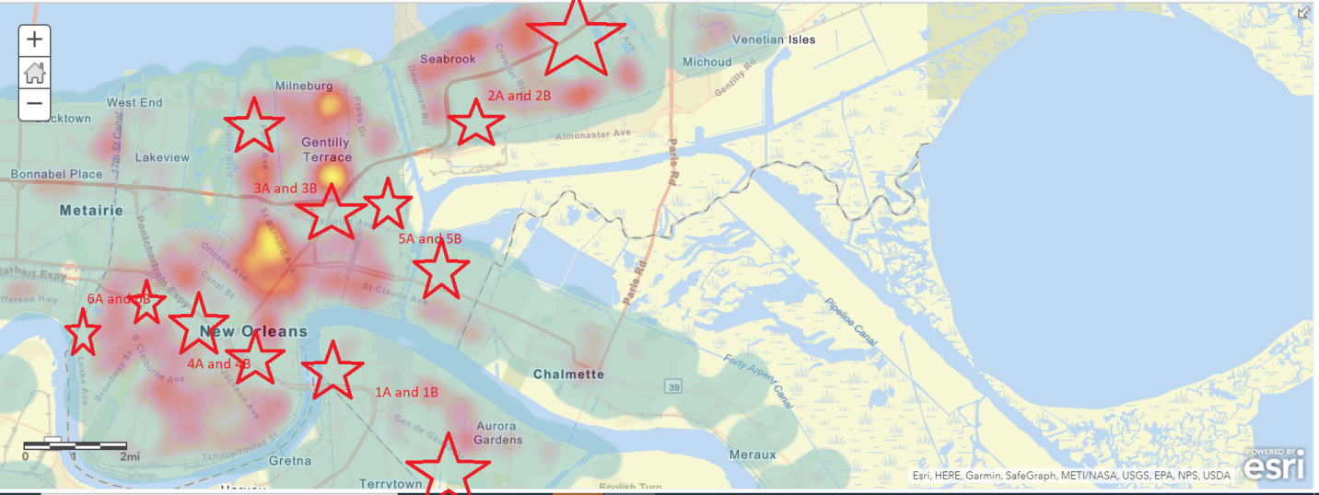
These areas largely represent communities with high poverty rates and individuals with significant vulnerabilities and existing chronic medical conditions.

Based on this information, the New Orleans Health Department immediately began plans for mobile testing, in order to bring services to those most disconnected and provide equitable access to a critical component of COVID-19 treatment and recovery. We have identified locations with ample, safe space where we can bring a full testing site for 3-4 days at a time in each “hotspot” that can easily be accessed by walking, biking, or driving. We are partnering with LCMC Health, a large local healthcare system, as well as LSU Health Sciences Center on program management and personnel, and working with the faith leaders and neighborhood groups in each area to help spread the word and bring community members to the sites.

Recognizing that the health burdens of this outbreak go beyond the virus to include the direct impacts of loss of economic security and social cohesion, the mobile testing sites will offer more than a simple COVID test. At each site, we plan to provide:

- Rapid viral testing for presence of active COVID-19 infection (turnaround time no more than 1-2 days)
- Brief assessment of individuals’ immediate basic needs and gaps that should be addressed
- On site personnel to immediately address behavioral health, food insecurity, maternal-child health, domestic violence, interpersonal violence, and other identified needs
- Resource sheets detailing available services for all of the above and more
- “Gift bags” with key items that may be in short supply – ideally cleaning supplies, face covering, hand sanitizer, and if possible a gift card for food/basic necessities purchase
- NOHD trained personnel to do direct call backs with test results (and to check on residents after the testing). Learning from the federal program, we realized how critical it is to have a trusted, local, culturally competent voice on the end of the phone line when discussing test results and next steps to keep individuals & household members safe.

Our current partnership with the institutions above will provide adequate level of resources to run approximately 250 tests per day; Tulane University is providing initial support for some number of gift bags. However, to support this program as robustly as our community deserves, we would seek to obtain increased funding for additional sites, testing, personnel, and resources. We are also exploring a model with the CORE Foundation (out of Los Angeles) that would allow us to become even more hyper-local: a smaller vehicle set up that could drive block by block and allow walk-up testing in the hardest to reach areas.

Access to testing, treatment, and resources during an outbreak should not be inequitably available and further exacerbate deep disparities in economics and health. Our community mobile testing program seeks to deliberately prioritize those in greatest need and at highest risk of poor outcomes, and helps to ensure New Orleans’ recovery from COVID-19 is even, fair, and beneficial to all.

